Assignment 5 report

1. Homework 1

We hacked the Radon Sensor LED display and connected the pins to the Edison board. Without turning on the Edison board, the LED display showed valid values like 3.3. However, when we turned on the Edison board the display value changed. This change is possible caused by the electric voltage interference between the Edison board and the Radon Sensor LED electrodes. The photo below shows that the value changed to “H.H”.

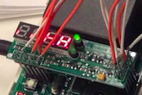

1. Homework 2

For this task, we modified the previous Arduino code of Assignment 4. We first need to register each pin for the 7 LED segments in the setup(). And then in the loop(), the value of each segment is saved to a integer value. All the integer values are saved to an integer array. And then run a loop to compare the read integer array with the stored LED pattern, we can get a number whether it is 1,2,3,4,5,6,7,8 or 9. This is the way we transform the number displayed on the LED screen to a numerical value.

However, since we can’t get a valid output from the radon sensor, the value transferred to Edison board is not correct. The collected sensor values are like those presented in the following figure:

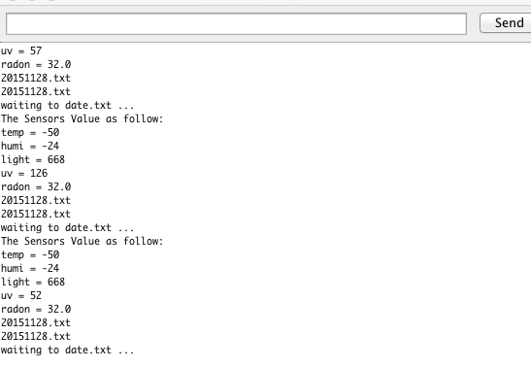

After getting the Radon sensor values, we incorporated the RTC codes into the Arduino codes to get the TimeStamp. We successfully saved the sensor values to a .txt file corresponding to the date.

